VENANGO TECHNOLOGY CENTER
JOINT COMMITTEE
1 Vo-Tech Drive
Oil City, Pennsylvania 16301

MINUTES

February 1, 2021

The regular meeting of the Venango Technology Center Joint Committee was held this evening in the Conference Room of the Venango Technology Center, 1 Vo-Tech Drive, Oil City, PA 16301. Mr. Come called the meeting to order at seven o’clock (7:00) p.m.

Mr. Come asked the members to pause for a moment of silence.

Mr. Come asked the members to stand for the pledge of allegiance.

Roll Call: Present: Todd Carson, Robert Blauser, James Disque, Jeff Thomas (zoom),
Mark Marterella (zoom), Andy Boland, Shari Neely, Troy Johnston (zoom),
James Come (zoom)

Absent: Don Judy

Also Present: Mr. Mario Fontanazza, Mrs. Stephanie Keebler (zoom)

Mr. Come stated the Joint Committee members had received copies of the Minutes of the January 4, 2021 meeting in the mail. He asked if there were any additions, corrections or deletions.

Mr. Carson, seconded by Mr. Marterella, moved to approve the Minutes of the January 4, 2021 meeting as submitted.

Roll Call: Ayes: Todd Carson, Robert Blauser, James Disque, Jeff Thomas, Mark Marterella,
Andy Boland, Shari Neely, Troy Johnston, James Come

Nayes: None, motion carried.

The Treasurer and Secretary’s Report as of 2/1/21 were submitted for information.

Mr. Marterella, seconded by Mr. Carson, moved to accept the Treasurer and Secretary’s Report as of 2/1/21 as submitted.

The motion was unanimously approved.

A list of bills from 1/5/21 – 2/1/21 in the amount of $629,683.78 was presented for approval.

Mr. Carson, seconded by Mr. Marterella, moved to approve the list of bills as presented.

Roll Call: Ayes: Todd Carson, Robert Blauser, James Disque, Jeff Thomas, Mark Marterella,
Andy Boland, Shari Neely, Troy Johnston, James Come

Nayes: None, motion carried.

Under Communications, Mr. Fontanazza discussed the Professional Advisory Committee. He also discussed the Calendar of Events for the month of January and the Monthly Enrollment Report as of 2/1/21 were submitted.

Mr. Come requested approval of the action items as presented. Item 8. a) i.- vi. in one motion.

Mr. Carson, seconded by Mr. Thomas, moved to approve action items i.- vi. as follows:

- Approve additions to Occupational Advisory Committees.
- Approve resolution authorizing James Come, Mark Marterella and Patrick Adams as the check signers for the payroll and General Fund accounts with Northwest Savings Bank and the General Fund PLGIT account.
- Accept Curt Crawford’s letter of intent to retire effective June 30, 2021.
- Approve posting and advertising for the Automotive Technology instructor position.
- Approve hiring Kelly Erwin as Administrative Assistant at a salary not to exceed $22,000 prorated based on the number of days worked.
- Approve Contract with Aegis Company for 3 year Asbestos inspection at a price not to exceed $3,675.00.

Roll Call: Ayes: Todd Carson, Robert Blauser, James Disque, Jeff Thomas, Mark Marterella,
Andy Boland, Shari Neely, Troy Johnston, James Come

Nayes: None, motion carried.

Mr. Fontanazza reviewed his Issues/Activities for January 2021.

Mr. Come asked if there was any old business.

None was noted.

Under New Business, Mr. Come requested approval of the 3 year copier lease with Hagan Business machines.

Mr. Carson, seconded by Mr. Disque, moved to approve the 3 year copier lease with Hagan Business machines.

Roll Call: Ayes: Todd Carson, Robert Blauser, James Disque, Jeff Thomas, Mark Marterella,
Andy Boland, Shari Neely, Troy Johnston, James Come

Nayes: None, motion carried.

Upon motion by Mr. Carson, seconded by Mr. Blauser, the meeting adjourned at ten minutes past seven (7:10) p.m.

Recorded by
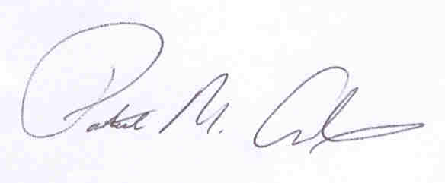
Patrick M. Adams
Secretary, Joint Committee

